Assignment 8

Swapnil Kamate

51. The Binder Prime Company wants to recognize the employee who sold the most of its products during a specified period. Write a query to display the employee number, employee first name, employee last name, email address, and total units sold for the employee who sold the most Binder Prime brand products between November 1, 2015, and December 5, 2015. If there is a tie for most units sold, sort the output by employee last name

Answer:

SELECT EMP.EMP_NUM, EMP_FNAME,EMP_LNAME, EMP_EMAIL, TOTAL

FROM LGEMPLOYEE AS EMP INNER JOIN

(SELECT EMPLOYEE_ID, SUM(LINE_QTY) AS TOTAL

FROM LGINVOICE AS I INNER JOIN LGLINE AS L ON I.INV_NUM = L.INV_NUM

INNER JOIN LGPRODUCT AS P ON L.PROD_SKU = P.PROD_SKU

INNER JOIN LGBRAND AS B ON B.BRAND_ID = P.BRAND_ID

WHERE BRAND_NAME = 'BINDER PRIME'

AND INV_DATE BETWEEN '2017-11-01' AND '2017-12-06'

GROUP BY EMPLOYEE_ID) AS SUB

ON EMP.EMP_NUM = SUB.EMPLOYEE_ID

WHERE TOTAL = (SELECT MAX(TOTAL)

FROM (SELECT EMPLOYEE_ID, SUM(LINE_QTY) AS TOTAL

FROM LGINVOICE AS I INNER JOIN LGLINE AS L ON I.INV_NUM = L.INV_NUM

INNER JOIN LGPRODUCT AS P ON L.PROD_SKU = P.PROD_SKU

INNER JOIN LGBRAND AS B ON B.BRAND_ID = P.BRAND_ID

WHERE BRAND_NAME = 'BINDER PRIME'

AND INV_DATE BETWEEN '2017-11-01' AND '2017-12-06'

GROUP BY EMPLOYEE_ID) AS SUB1)

ORDER BY EMP_LNAME;

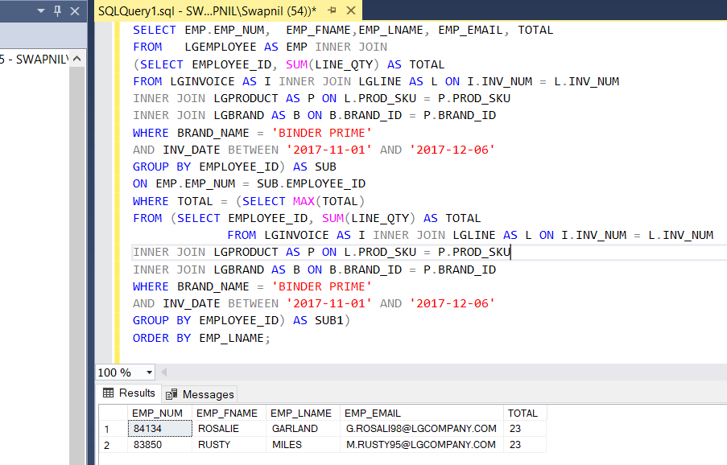

52. Write a query to display the customer code, first name, and last name of all customers who have had at least one invoice completed by employee 83649 and at least one invoice completed by employee 83677. Sort the output by customer last name and then first name (Figure P7.52).

Answer:

SELECT DISTINCT F1.CUST_CODE, F1.CUST_FNAME, F1.CUST_LNAME

FROM (SELECT C.CUST_CODE, C.CUST_FNAME, C.CUST_LNAME

FROM LGCUSTOMER C, LGINVOICE I

WHERE C.CUST_CODE=I.CUST_CODE AND EMPLOYEE_ID=83649)F1,

(SELECT C.CUST_CODE, C.CUST_FNAME, C.CUST_LNAME

FROM LGCUSTOMER C, LGINVOICE I

WHERE C.CUST_CODE=I.CUST_CODE

AND EMPLOYEE_ID=83677)F2

WHERE F1.CUST_CODE=F2.CUST_CODE

ORDER BY F1.CUST_LNAME, F1.CUST_FNAME;

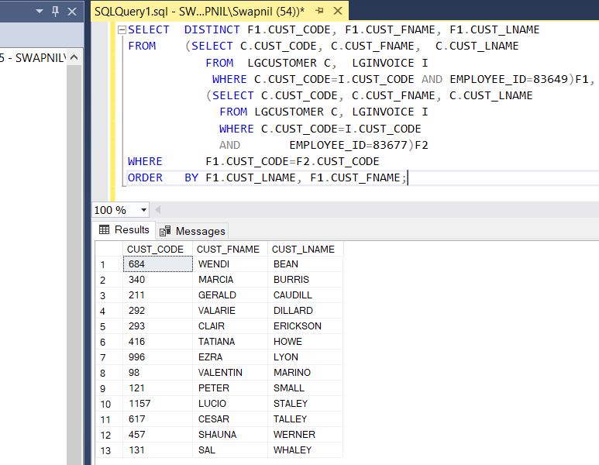

53. LargeCo is planning a new promotion in Alabama (AL) and wants to know about the largest purchases made by customers in that state. Write a query to display the customer code, customer first name, last name, full address, invoice date, and invoice total of the largest purchase made by each customer in Alabama. Be certain to include any customers in Alabama who have never made a purchase; their invoice dates should be NULL and the invoice totals should display as 0. Sort the results by customer last name and then first name (Figure P7.53).

Answer:

SELECT C.CUST_CODE, C.CUST_FNAME, C.CUST_LNAME, C.CUST_STREET, C.CUST_CITY, C.CUST_STATE, C.CUST_ZIP, I.INV_DATE, I.INV_TOTAL AS 'LARGEST INVOICE'

FROM LGCUSTOMER C, LGINVOICE I

WHERE I.CUST_CODE = C.CUST_CODE

AND C.CUST_STATE = 'AL'

AND I.INV_TOTAL = (SELECT MAX(I2.INV_TOTAL) FROM LGINVOICE I2 WHERE I2.CUST_CODE =

C.CUST_CODE)

UNION

SELECT C2.CUST_CODE, C2.CUST_FNAME, C2.CUST_LNAME, C2.CUST_STREET, C2.CUST_CITY,

C2.CUST_STATE, C2.CUST_ZIP, NULL, 0

FROM LGCUSTOMER C2

WHERE C2.CUST_STATE = 'AL'

AND C2.CUST_CODE NOT IN (SELECT I3.CUST_CODE FROM LGINVOICE I3)

ORDER BY CUST_LNAME, CUST_FNAME;

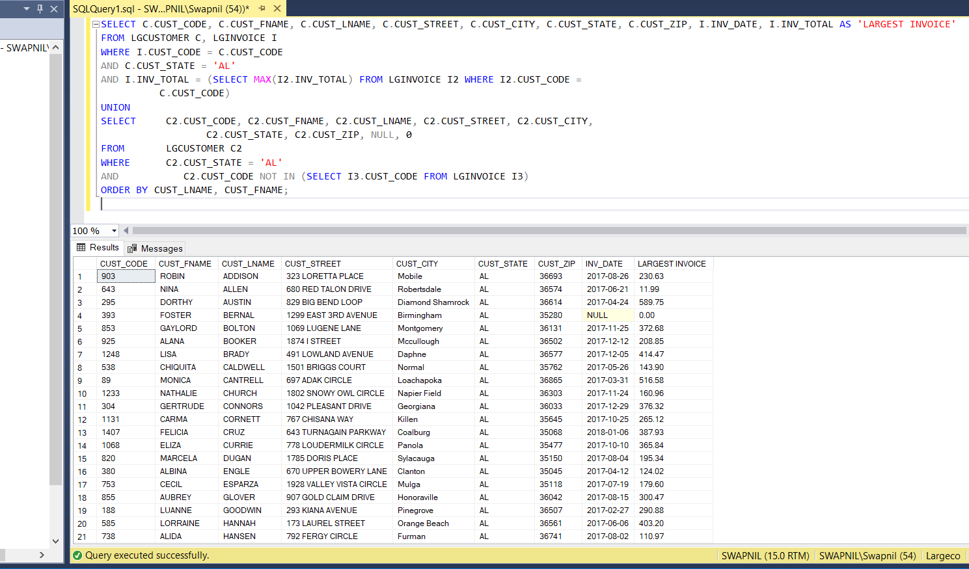

54. One of the purchasing managers is interested in the impact of product prices on the sale of products of each brand. Write a query to display the brand name, brand type, average price of products of each brand, and total units sold of products of each brand. Even if a product has been sold more than once, its price should only be included once in the calculation of the average price. However, you must be careful because multiple products of the same brand can have the same price, and each of those products must be included in the calculation of the brand’s average price. Sort the result by brand name (Figure P7.54).

Answer:

SELECT F1.BRAND_NAME, F1.BRAND_TYPE, ROUND(F1.AVERAGE_PRICE,2) AS AVGPRICE, F2.AMT_SOLD AS UNITS_SOLD

FROM ( SELECT B.BRAND_NAME AS BRAND_NAME, B.BRAND_TYPE AS BRAND_TYPE, B.BRAND_ID AS BRAND_ID, (SUM(P.PROD_PRICE)/COUNT(DISTINCT P.PROD_SKU)) AS AVERAGE_PRICE

FROM LGPRODUCT P, LGBRAND B

WHERE B.BRAND_ID=P.BRAND_ID

GROUP BY B.BRAND_ID

ORDER BY B.BRAND_NAME)F1,

(SELECT B.BRAND_ID AS BRAND_ID, SUM(L.LINE_QTY) AS AMT_SOLD

FROM LGBRAND B, LGLINE L, LGPRODUCT P

WHERE B.BRAND_ID=P.BRAND_ID

AND P.PROD_SKU=L.PROD_SKU

GROUP BY B.BRAND_ID

ORDER BY B.BRAND_NAME)F2

WHERE F1.BRAND_ID=F2.BRAND_ID;

55.The purchasing manager is still concerned about the impact of price on sales. Write a query to display the brand name, brand type, product SKU, product description, and price of any products that are not a premium brand, but that cost more than the most expensive premium brand products (Figure P7.55).

Answer:

SELECT B.BRAND_NAME AS BRAND_NAME, B.BRAND_TYPE AS BRAND_TYPE, P.PROD_SKU AS PROD_SKU, P.PROD_DESCRIPT, P.PROD_PRICE AS PROD_PRICE

FROM LGBRAND B, LGPRODUCT P

WHERE B.BRAND_ID=P.BRAND_ID

AND B.BRAND_TYPE NOT IN ('PREMIUM') AND P.PROD_PRICE >

(SELECT MAX(P.PROD_PRICE)

FROM LGBRAND B, LGPRODUCT P

WHERE B.BRAND_ID=P.BRAND_ID

AND B.BRAND_TYPE = 'PREMIUM');

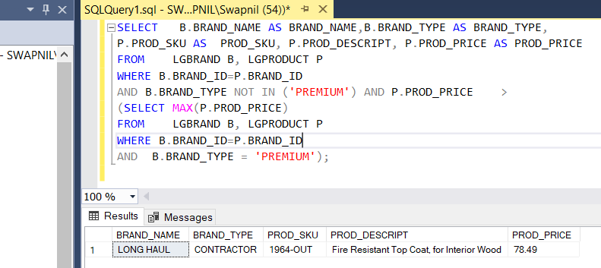

56. Write a query that displays the book title, cost and year of publication for every book in the system. Sort the results by book title.

Answer:

SELECT BOOK_TITLE,BOOK_COST,BOOK_YEAR

FROM BOOK

ORDER BY BOOK_TITLE

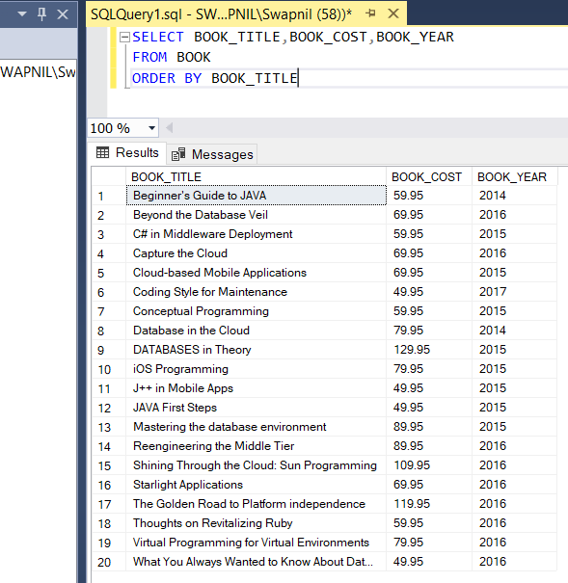

57. Write a query that displays the first and last name of every patron, sorted by last name and then first name. Ensure the sort is case insensitive (Figure P7.57). (50 rows)

Answer:

SELECT PAT_FNAME,PAT_LNAME

FROM PATRON

ORDER BY PAT_LNAME,PAT_FNAME

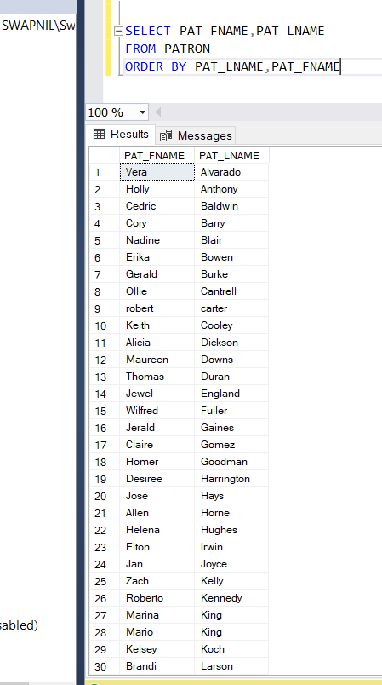

58. Write a query to display the checkout number, checkout date, and due date for every book that has been checked out sorted by checkout number (Figure P7.58). (68 rows)

Answer:

SELECT CHECK_NUM,CHECK_OUT_DATE,CHECK_DUE_DATE

FROM CHECKOUT

ORDER BY CHECK_NUM

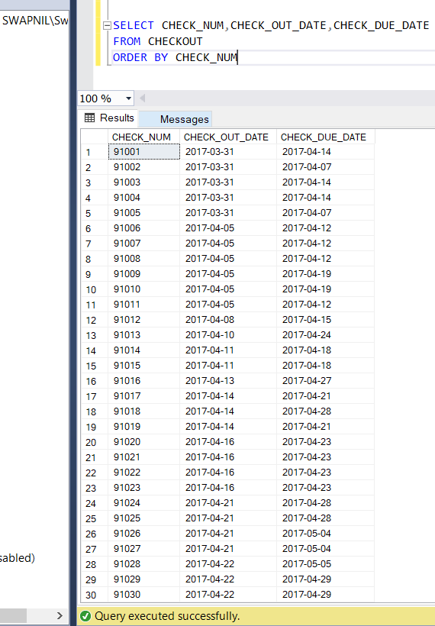

59. Write a query to display the book number, book title, and subject for every book sorted by book number (Figure P7.59). (20 rows)

Answer:

SELECT BOOK_NUM,BOOK_TITLE,BOOK_SUBJECT

FROM BOOK

ORDER BY BOOK_NUM

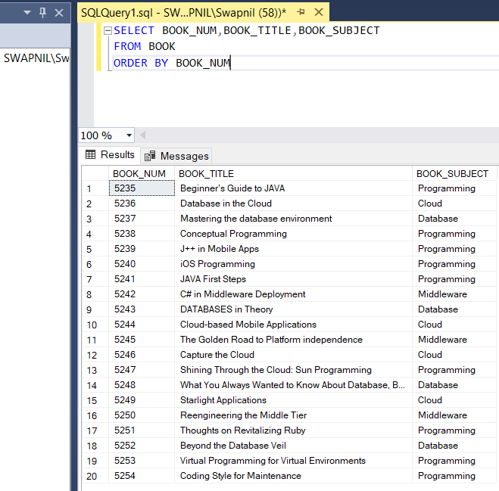

60. Write a query to display the different years in which books have been published. Include each year only once and sort the results by year (Figure P7.60).

Answer:

SELECT DISTINCT BOOK_YEAR FROM BOOK

ORDER BY BOOK_YEAR

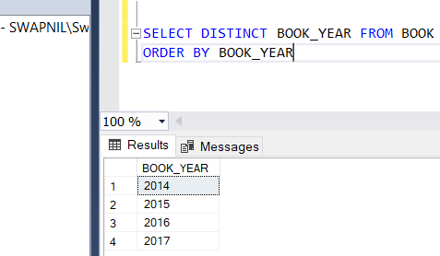

61.Write a query to display the different subjects on which FACT has books. Include each subject only once and sort the results by subject (Figure P7.61).

Answer:

SELECT DISTINCT BOOK_SUBJECT

FROM BOOK

ORDER BY BOOK_SUBJECT

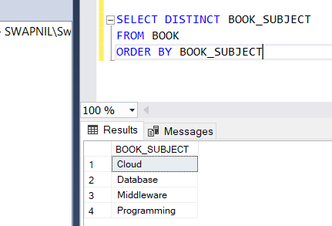

62.Write a query to display the book number, title, and cost of each book sorted by book number (Figure P7.62).

Answer:

SELECT BOOK_NUM,BOOK_TITLE,BOOK_COST

FROM BOOK

ORDER BY BOOK_NUM

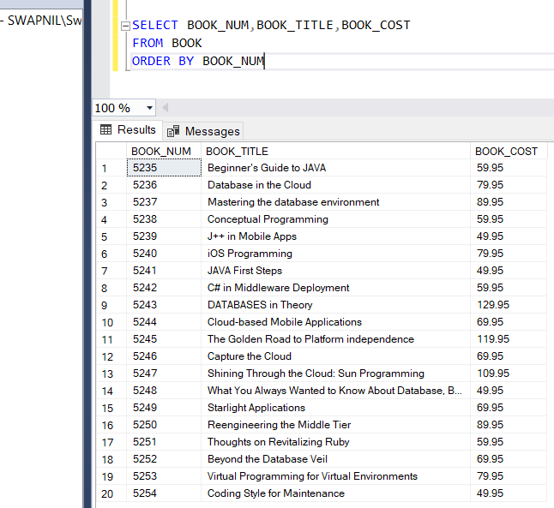

63. Write a query to display the checkout number, book number, patron ID, checkout date, and due date for every checkout that has ever occurred in the system. Sort the results by checkout date in descending order and then by checkout number in ascending order (Figure P7.63). (68 rows)

Answer:

SELECT CHECK_NUM,BOOK_NUM,PAT_ID,CHECK_OUT_DATE,CHECK_DUE_DATE

FROM CHECKOUT

ORDER BY CHECK_OUT_DATE DESC ,CHECK_NUM ASC

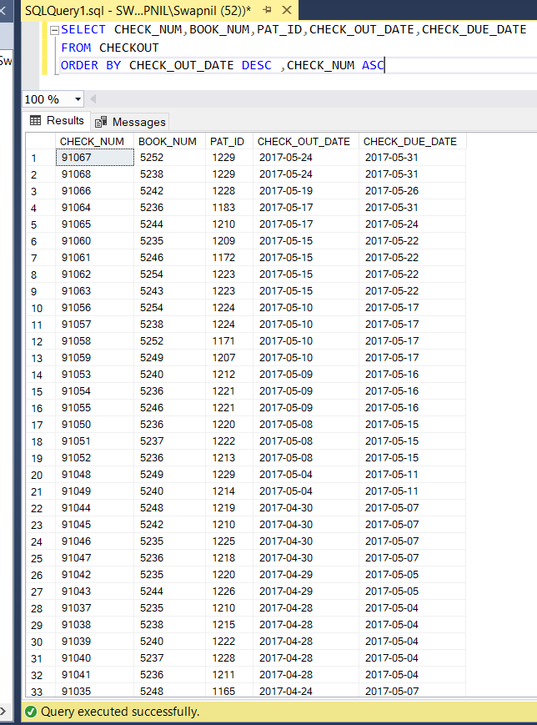

64. Write a query to display the book title, year, and subject for every book. Sort the results by book subject in ascending order, year in descending order, and then title in ascending order (Figure P7.64). (20 rows)

Answer:

SELECT BOOK_TITLE,BOOK_YEAR,BOOK_SUBJECT

FROM BOOK

ORDER BY BOOK_SUBJECT ASC,BOOK_YEAR DESC, BOOK_TITLE ASC

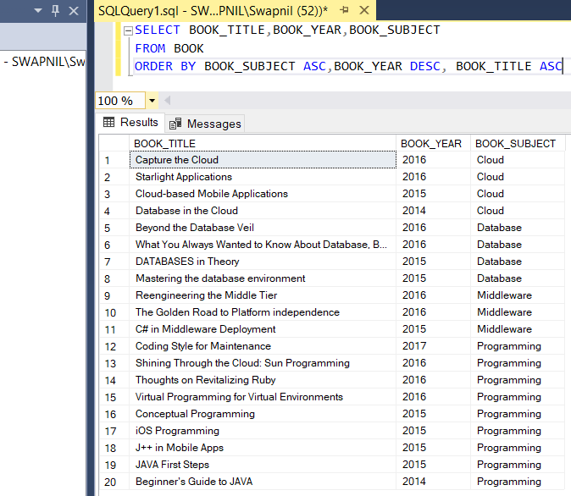

65. Write a query to display the book number, title, and cost for all books that cost $59.95 sorted by book number (Figure P7.65).

Answer:

SELECT BOOK_NUM,BOOK_TITLE,BOOK_COST

FROM BOOK

WHERE BOOK_COST = 59.95

ORDER BY BOOK_NUM

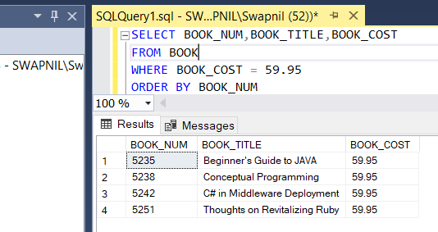

66. Write a query to display the book number, title, and replacement cost for all books in the “Database” subject sorted by book number (Figure P7.66).

Answer:

SELECT BOOK_NUM,BOOK_TITLE,BOOK_COST

FROM BOOK

WHERE BOOK_SUBJECT='Database'

ORDER BY BOOK_NUM

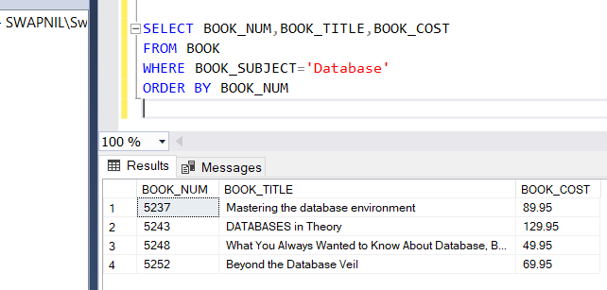

67. Write a query to display the checkout number, book number, and checkout date of all books checked out before April 5, 2017 sorted by checkout number (Figure P7.67).

Answer:

SELECT CHECK_NUM,BOOK_NUM,CHECK_OUT_DATE

FROM CHECKOUT

WHERE CHECK_OUT_DATE < '2017-04-05'

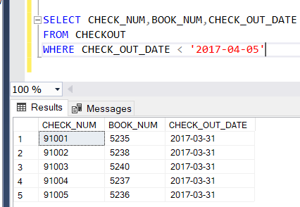

68. Write a query to display the book number, title, and year of all books published after 2015 and on the “Programming” subject sorted by book number (Figure P7.68).

Answer:

SELECT BOOK_NUM,BOOK_TITLE,BOOK_YEAR

FROM BOOK

WHERE BOOK_YEAR > 2015 AND BOOK_SUBJECT = 'Programming'

ORDER BY BOOK_NUM

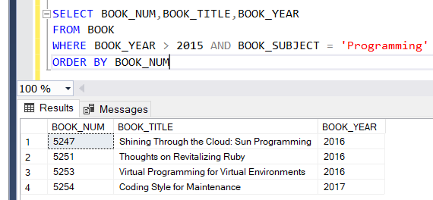

69.Write a query to display the book number, title, subject, and cost for all books that are on the subjects of “Middleware” or “Cloud,” and that cost more than $70 sorted by book number (Figure P7.69).

Answer:

SELECT BOOK_NUM,BOOK_TITLE,BOOK_SUBJECT,BOOK_COST

FROM BOOK

WHERE BOOK_COST > 70 AND (BOOK_SUBJECT = 'Cloud' OR BOOK_SUBJECT='Middleware')

ORDER BY BOOK_NUM

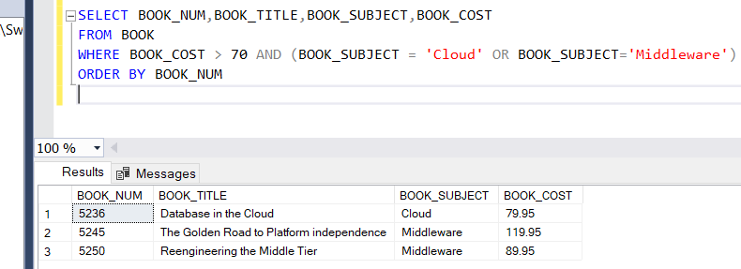

70.Write a query to display the author ID, first name, last name, and year of birth for all authors born in the decade of the 1980s sorted by author ID (Figure P7.70).

Answer:

SELECT * FROM AUTHOR

WHERE AU_BIRTHYEAR BETWEEN 1980 AND 1989

ORDER BY AU_ID

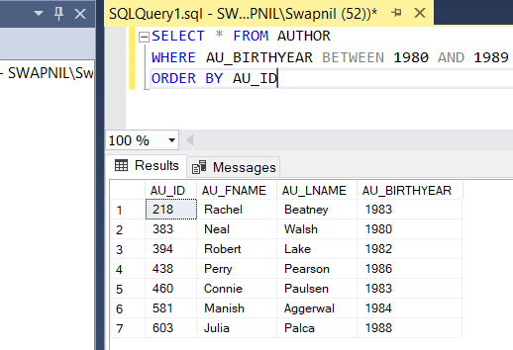

**Leet Code Example**

Write a SQL query for a report that provides the following information for each person in the Person table, regardless of if there is an address for each of those people:

select p.Firstname,p.Lastname,a.City,a.State

from Person as p

left join Address as a

on p.PersonId = a.PersonID

